Interface design and database design.

Interface design.

List of interface pages
No. | Page Name | Description
1 | Home page | Main screen; allows searching for rooms by keyword or by selecting check-in and check-out dates.
2 | View room | Filters room information by Room ID, check-in date, check-out date, guest capacity, maximum price, minimum price, room availability status, and rating.
3 | View room detail | Displays detailed room information, allows selecting check-in/check-out dates, number of adults and children, and adding extra services to make a reservation.
4 | My booking | Displays all booked rooms and allows canceling eligible bookings.
5 | Booking page | Summarizes the total amount after clicking to book. If the user is not logged in, it automatically redirects to the Sign-in page; if logged in, it redirects to the Payment page.
6 | Sign in | Logs users in via email and password with a "Remember Me" option. Includes a redirect link/button to the Sign-up page if the user doesn't have an account, and to the Reset Password page if they forgot their password.
7 | Sign up | Allows users to create a new account by entering their email or phone number, password, and full name. Features a show/hide password toggle for convenience. Users confirm registration with the "Sign up" button, or use the "Sign in" button to redirect to the login page if they already have an account.
8 | Forgot Password | Allows users to create a new password when they forget their old one by providing their phone number or email address.
9 | Payment page | Allows reviewing the invoice and selecting a bank transfer payment method. Upon successful transfer, it navigates to the Payment successful page.
10 | Payment successful | Displays a summary of room booking details, sends a confirmation notification via email, and provides options to return to the Home page or view booking history.
11 | Cancel booking | Confirms the room to be canceled and agrees to policies; users can either cancel the request or proceed to receive a refund and navigate back to the Home page.
12 | Update profile | Accessible from most pages via the Profile section; allows users to fill in additional personal information (then return to Home) or change their password.
13 | Change password | Requires entering the old password, new password, and confirming the new password. Users press Enter to save and return to Home, or click Cancel to return to Home.
14 | Review form | Allows users to select star ratings, enter descriptions, upload photos, and view existing reviews. Users can submit or cancel to return to the Home page.
15 | Manage booking | Allows staff/admins to check booking statuses and accept/reject reservations: ticking an empty checkbox approves it, an untouched box means pending, and clicking the "X" button rejects it (highlighted in red).
16 | Manage user | Displays a user list with User ID, Full Name, National ID/Passport, Address, and Account Status, with capabilities to lock/unlock accounts.  Includes navigation to the Create customer account page for walk-in guests.
17 | Create customer account | Allows staff to fill in details and make a booking for walk-in customers (Full Name, Gender, Phone Number, Address, Date of Birth, Temporary Password, National ID/Passport, and Reserved Room ID).
18 | Manage room | Allows adding new room information (Room ID, Room Number, Price per Night, Area, Capacity, Room Type, Description, and Images).  Allows viewing updated room details, with options to edit or delete rooms.
19 | Revenue report | Displays basic information on booked rooms (Customer ID, Room ID, Total Price, Additional Services, and Status such as payment status, payment method, and room occupancy status).  If paid, staff must confirm to verify successful transaction; if unpaid, status can be updated (Checking in, Checked out, or adding additional incurred charges).
20 | Manage voucher | Manages voucher details (Voucher Code, Discount Rate/Amount, Start Date, End Date, and Application Conditions).  Allows viewing updated vouchers and their current status.
21 | Manage service | Manages service information including Service ID, Service Name, and Detailed Description.  Displays information for all updated/existing services.

Interface specification

LOGIN screens

LOGIN page
Figure: Sign in
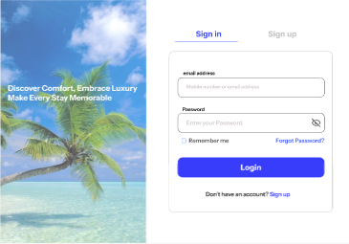
Actor: Guest
General description: Allows a user to log in with an email and password. After a successful login, the system redirects the user to the page that matches the user’s role.
No. | Control | Type | Constraints | Function and handling
1 | Email address | Text box | Required, valid email format | Enter the registered email.
2 | Password | Text box (masked) | Required | Enter the password.
3 | Eye icon | Button | None | Show or hide the password.
4 | Remember me | Check box | Optional | Keep the login session for longer.
5 | Forgot Password? | Link | None | Open the FORGOT PASSWORD page.
6 | Login | Button | None | Check the email and password. Correct: a Customer goes to the page they were trying to reach (if any) or the HOME page; an Admin goes to the MANAGE BOOKINGS tab. Incorrect: show an error and record the number of failed attempts. More than 3 failed attempts: temporarily lock login for 15 minutes and send a warning email. Account locked by Admin: tell the user to contact the hotel.
7 | Sign up | Link, tab | None | Open the SIGN UP page.

FORGOT PASSWORD page
Figure: Forgot password
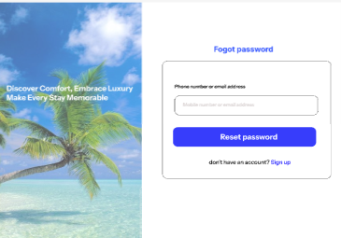
Actor: Guest
General description: The user enters an email address to receive a new password by email.
No. | Control | Type | Constraints | Function and handling
1 | Email address | Text box | Required, valid email format | Enter the registered email.
2 | Reset password | Button | None | Email exists: generate a random new password that follows the password rules, send it to the email, and show the result. Email does not exist: show an error. Sending the email fails: show an error and keep the old password.
3 | Sign up | Link | None | Open the SIGN UP page.
4 | Back to sign in | Link | None | Open the LOGIN page.

SIGN UP page
Figure: Sign up
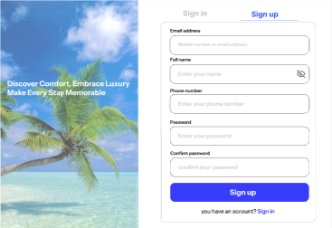
Actor: Guest
General description: Creates a new customer account.
No. | Control | Type | Constraints | Function and handling
1 | Full name | Text box | Required | Enter the full name.
2 | Email | Text box | Required, valid format, not already registered | Enter the email used to log in.
3 | Phone number | Text box | Required, valid format, stored as a string | Enter the phone number.
4 | Password | Text box (masked) | At least 8 characters with lowercase, uppercase, a digit and a special character | Enter the password.
5 | Confirm password | Text box (masked) | Must match Password | Re-enter the password.
6 | Sign up | Button | None | Valid: encrypt the password, create an account with the Customer role, show a success message and go to the LOGIN page. Duplicate email or invalid data: show an error that points to the wrong field.
7 | Sign in | Link, tab | None | Open the LOGIN page.

Main screens

HOME page
Figure: Home
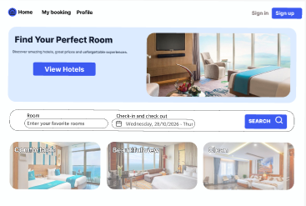
Actor: Guest, Customer, Admin
General description: Introduces the hotel and lets users search for rooms quickly.
No. | Control | Type | Constraints | Function and handling
1 | Menu (Home, Rooms, Profile) | Link | Profile is shown only after login | Go to the selected page.
2 | Sign in, Sign up | Button | Shown to Guest only | Open the LOGIN or SIGN UP page.
3 | Logout | Button | Shown after login only | End the session and return to the HOME page.
4 | View Rooms | Button | None | Open the ROOM LIST page.
5 | Room | Text box | Optional | Enter a room name or room ID.
6 | Check-in and check-out | Date range picker | Check-in not before today; check-out after check-in | Choose the stay period.
7 | Guests | Number box | Greater than 0 | Enter the number of guests.
8 | SEARCH | Button | None | Validate the criteria. Valid: open the ROOM LIST page with the filtered results. Invalid: show an error.
9 | Three photo cards (Comfortable, Beautiful view, Clean) | Clickable card | None | Open the ROOM LIST page for the selected room group.

VIEW HOME page
Figure: View home
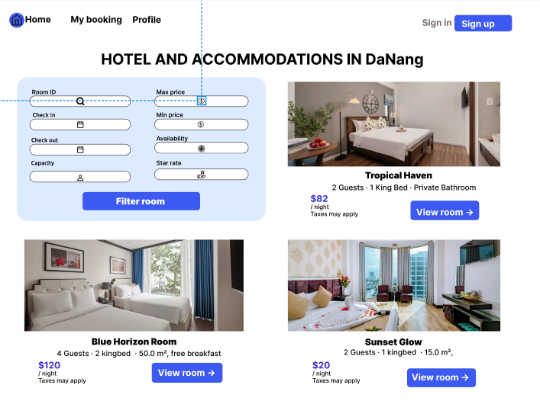
Actor: Guest, Customer, Admin
General description: Shows the rooms of the hotel and supports searching, filtering and paging (10 rooms per page). Results are returned within 3 seconds.
No. | Control | Type | Constraints | Function and handling
1 | Room ID | Text box | Optional | Search by room ID.
2 | Check in, Check out | Date picker | Check-out after check-in | Show only rooms available in the period.
3 | Capacity | Drop-down list | Positive integer | Filter by capacity.
4 | Min price, Max price | Number box | Not negative; Min ≤ Max | Filter by price range.
5 | Availability | Drop-down list | None | Filter by availability.
6 | Star rate | Drop-down list | None | Filter by average rating.
7 | Filter room | Button | None | Reload the list. No match: show “No rooms found” and suggest changing the criteria.
8 | Room card (photo, name, capacity, price per night) | Display block | None | Show summary information with a “taxes may apply” note.
9 | View room | Button | None | Open the ROOM DETAIL page.
10 | Page numbers | Link | None | Go to another page of results.

VIEW ROOM DETAIL page
Figure: View room detail
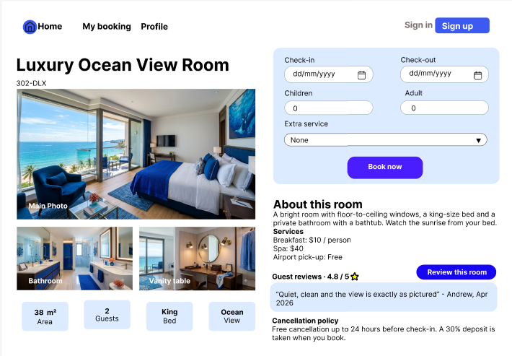
Actor: Guest, Customer, Admin
General description: Shows full information about one room and is the starting point for booking. Every user can see rooms and prices.
No. | Control | Type | Constraints | Function and handling
1 | Main photo, other photos | Image | None | Click to enlarge.
2 | Facts (area, guests, bed, view) | Label | Read-only | Display room facts.
3 | About this room, Services | Text block | Read-only | Show the description, included services and prices.
4 | Price per night, availability | Label | Read-only | Shown in the booking panel.
5 | Check-in, Check-out | Date picker | Valid period | Check that the room is available.
6 | Children, Adult | Number box | Not negative; total not above capacity | Enter the number of guests.
7 | Extra service | Multi-select list | Optional | Choose extra services; their prices are added to the total on the BOOKING page.
8 | Book now | Button | None | Guest: go to the LOGIN page and return afterwards. Customer: open the BOOKING page with the selected data. Room not available: show an error.
9 | Review this room | Button | Shown only to a Customer with a Completed booking of this room | Open the ROOM REVIEW page.
10 | Guest reviews | Display block | Read-only | Show the average rating and recent reviews.
11 | Cancellation policy | Text block | Read-only | Free cancellation up to 24 hours before check-in; 30% deposit.

BOOKING page
Figure: Booking
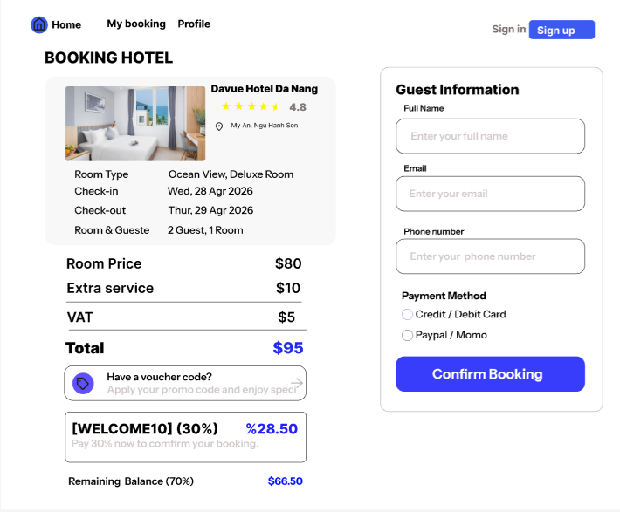
Actor: Customer
General description: Confirms the booking information, applies a voucher and shows the cost.
No. | Control | Type | Constraints | Function and handling
1 | Room summary (hotel, room type, dates, guests) | Label | Read-only | Taken from the ROOM DETAIL page.
2 | Room Price, Extra service, VAT, Total | Label | Read-only | Calculated automatically: price × nights + services + tax − discount. Example total: $95.
3 | Have a voucher code? | Text box with arrow button | Optional | Check the code. Valid: show the discount line and recalculate. Invalid: show the reason (expired, inactive, no uses left).
4 | Deposit (30%) | Label | Read-only | 30% of the total after discount, for example $28.50.
5 | Remaining Balance (70%) | Label | Read-only | The remaining amount paid at the hotel, for example $66.50.
6 | Full Name, Email, Phone number | Text box | Required, valid format | Pre-filled from the profile; can be changed if the occupant is not the person booking.
7 | Special requests | Text box | Optional | Enter special requests.
8 | Confirm Booking | Button | None | Check that the room is still free, hold it for 15 minutes and open the PAYMENT page. Room taken: show a message and return to the ROOM LIST page.

PAYMENT page
Figure: Payment
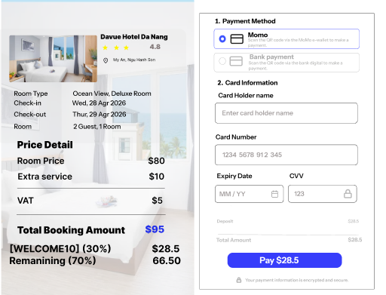
Actor: Customer (the Payment System processes the transaction)
General description: Chooses a payment method and pays the deposit. The system does not store card information.
No. | Control | Type | Constraints | Function and handling
1 | Order summary and Price Detail | Label | Read-only | Lets the customer confirm once more. Shows a 15-minute room-hold countdown.
2 | Credit / Debit Card | Option button | Choose one | Show the card input section.
3 | E-Wallet | Option button | Choose one | Go to the wallet of the Payment System.
4 | Pay at hotel | Option button | Choose one | Skip the payment gateway, record the booking as Pending and open the PAYMENT SUCCESSFUL page.
5 | Card Holder name, Card Number, Expiry Date, CVV | Text box | Required, valid format | Handled by the Payment System; the hotel system does not store them.
6 | Pay $28.50 | Button | None | Send the deposit to the Payment System. Success: record the deposit and open the PAYMENT SUCCESSFUL page. Failure: show an error and allow retrying, choosing Pay at hotel, or stopping (the room is released). After 15 minutes: release the room and show a time-out message.

PAYMENT SUCCESSFUL page
Figure: Payment Successful
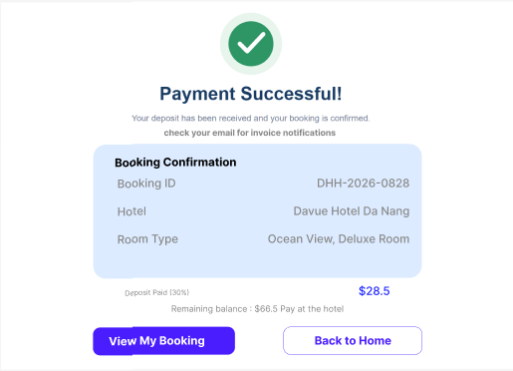
Actor: Customer
General description: Shows the booking result and confirms that the invoice and confirmation email were sent.
No. | Control | Type | Constraints | Function and handling
1 | Booking Confirmation (Booking ID, Hotel, Room Type) | Label | Read-only | Information of the new booking, status Pending.
2 | Deposit Paid (30%) | Label | Read-only | $28.50.
3 | Remaining balance | Label | Read-only | $66.50, paid at the hotel.
4 | Email notice | Label | Read-only | The invoice and confirmation email have been sent.
5 | View My Booking | Button | None | Open the MY BOOKINGS page.
6 | Back to Home | Button | None | Open the HOME page.

MY BOOKINGS page
Figure: My booking
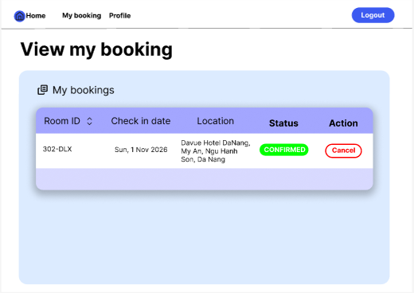
Actor: Customer (sees own bookings only)
General description: Lists the customer’s bookings, newest first, with their status and available actions.
No. | Control | Type | Constraints | Function and handling
1 | Table (Booking ID, Room ID, Check in, Check out, Location, Total, Status) | Table | Read-only | Show the bookings. No bookings: show a “no bookings yet” message.
2 | Sort icon | Button | None | Change the sort order by column.
3 | View details | Link | None | See services, voucher, deposit, tax and payments made.
4 | Cancel | Button | Shown only for Pending and Confirmed | Open the CANCEL BOOKING window.
5 | Review | Button | Shown only for Completed | Open the ROOM REVIEW page.
6 | contact support | Button | None | Show the hotel’s contact information.

CANCEL BOOKING window
Figure: Cancel booking
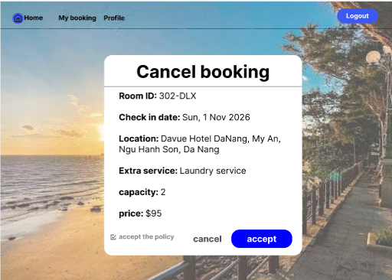
Actor: Customer (the Payment System takes part when a refund is made)
General description: Confirms a cancellation under the hotel’s cancellation policy.
No. | Control | Type | Constraints | Function and handling
1 | Room ID, Check in date, Location, Extra service, capacity, price | Label | Read-only | Information of the booking to be cancelled.
2 | Policy and refund amount | Label | Read-only | Free cancellation up to 24 hours before check-in, for example a $28.50 refund. Less than 24 hours: warn that the deposit is not refunded.
3 | accept the policy | Check box | Must be ticked to enable confirmation | The customer agrees to the policy.
4 | Keep booking | Button | None | Close the window and keep the booking unchanged.
5 | Confirm cancellation | Button | None | Change the booking to Cancelled and release the room. If the deposit was paid online and cancellation is free, send a refund request to the Payment System. Show the result and return to the MY BOOKINGS page.

ROOM REVIEW page
Figure: Review
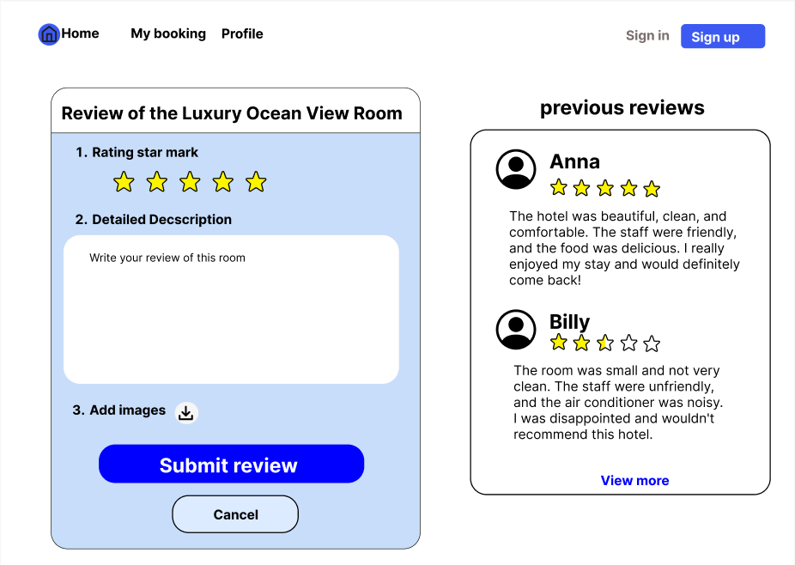
Actor: Customer with a Completed booking of the room
General description: Rates a stay and writes a comment. Each booking can be reviewed only once.
No. | Control | Type | Constraints | Function and handling
1 | Rating star mark | 5 stars | Integer from 1 to 5 | Choose the rating.
2 | Detailed Description | Text box | Required | Enter the comment.
3 | Submit review | Button | None | Check the conditions (own booking, Completed, not yet reviewed), save the review and show it on the ROOM DETAIL page.
4 | Cancel | Button | None | Discard and return to the previous page.
5 | previous reviews | Display block | Read-only | Reviews from other guests.
6 | View more | Link | None | Show more reviews.

PROFILE page
Figure: Personal Information
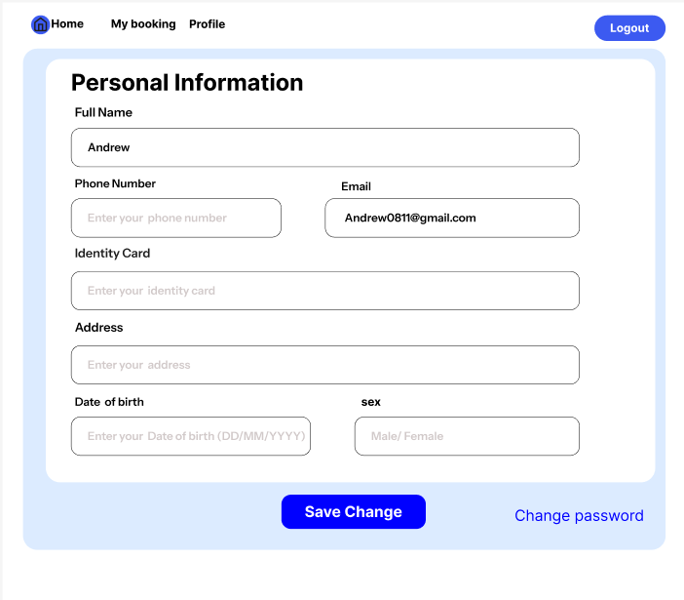
Actor: Customer
General description: Views and updates the customer’s own personal information.
No. | Control | Type | Constraints | Function and handling
1 | Full Name | Text box | Required | Edit the full name.
2 | Phone Number | Text box | Required, valid format | Edit the phone number.
3 | Email | Read-only box | Cannot be changed | Display the email.
4 | Identity Card | Text box | Stored as a string | Edit the ID card number.
5 | Address | Text box | Optional | Edit the address.
6 | Date of birth | Date picker | Format DD/MM/YYYY | Edit the date of birth.
7 | sex | Drop-down list | Male or Female | Edit the sex.
8 | Save Change | Button | None | Validate and save. Invalid data: show an error.
9 | Change password | Link | None | Open the CHANGE PASSWORD page.

CHANGE PASSWORD page
Figure: Change password
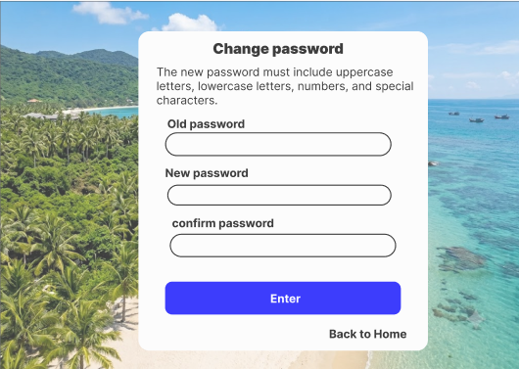
Actor: Customer, Admin
General description: Changes the password; the system sends an email notice when the change succeeds.
No. | Control | Type | Constraints | Function and handling
1 | Old password | Text box (masked) | Required, must be correct | Enter the current password.
2 | New password | Text box (masked) | At least 8 characters with lowercase, uppercase, a digit and a special character; different from the old password | Enter the new password.
3 | confirm password | Text box (masked) | Must match the new password | Re-enter the new password.
4 | Change password | Button | None | Valid: update the password, send an email notice and show the result. Invalid: show an error that points to the wrong field.
5 | Back to Home | Link | None | Open the HOME page.

MANAGE BOOKINGS tab
Figure: Manage Booking
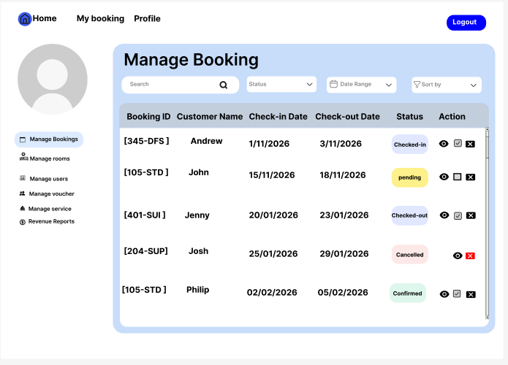
Actor: Admin
General description: Views all bookings, approves or cancels them.
No. | Control | Type | Constraints | Function and handling
1 | Search | Search box | Optional | Search by booking ID or customer name.
2 | Status | Drop-down list | None | Filter by status.
3 | Date Range | Date picker | None | Filter by date range.
4 | Sort by | Drop-down list | None | Sort the list.
5 | Table (Booking ID, Customer Name, Check-in, Check-out, Status) | Table | Read-only | Show the bookings.
6 | Eye icon | Button | None | View booking details.
7 | Pencil icon (Approve) | Button | Pending bookings only | Approve the booking and change it to Confirmed.
8 | X icon | Button | None | Cancel the booking after confirmation, applying the refund policy.

REVENUE REPORT tab
Figure: Revenue report
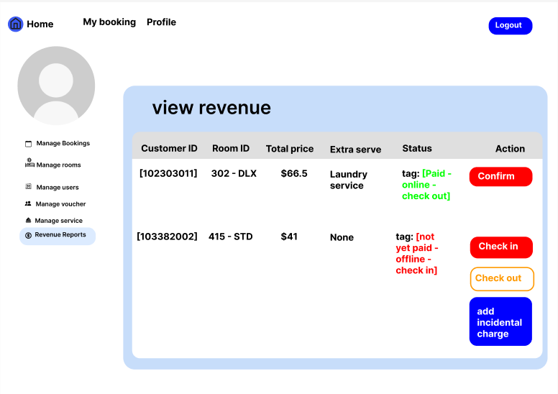
Actor: Admin
General description: Handles guests arriving and leaving, including walk-in guests.
No. | Control | Type | Constraints | Function and handling
1 | Table (Customer ID, Room ID, Total price, Extra service, Status) | Table | Read-only | List of bookings to handle, showing whether payment was made online.
2 | Check in | Button | Enabled for Confirmed bookings only | Compare the ID card with the booking information and change the booking to Checked-in.
3 | add incidental charge | Button | Checked-in bookings only | Open a form for the amount (not negative) and the reason; save and recalculate the total.
4 | Check out | Button | Enabled for Checked-in bookings only | Finalize charges, recalculate the total, issue the invoice, change the booking to Completed and free the room.

MANAGE USERS tab
Figure: Manage Users
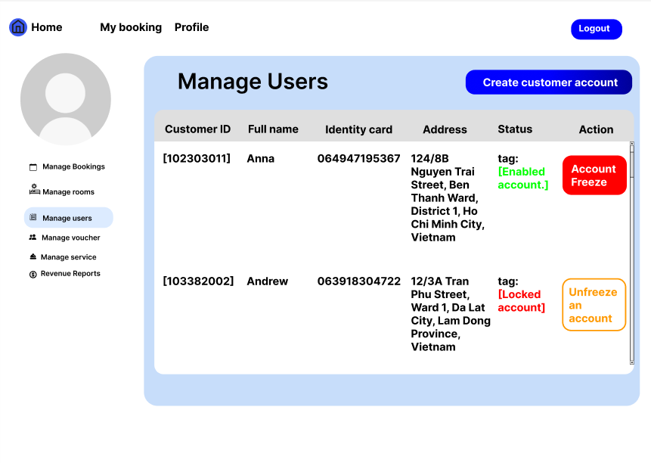
Actor: Admin
General description: Lists customers and locks or unlocks accounts.
No. | Control | Type | Constraints | Function and handling
1 | Table (Customer ID, Full name, Identity card, Address, Status) | Table | Read-only | Status is Enabled account or Locked account.
2 | Create customer account | Button | None | Open the CREATE CUSTOMER ACCOUNT window.
3 | Account Freeze | Button | Shown for Enabled accounts only | Lock the account; the customer can no longer log in.
4 | Unfreeze an account | Button | Shown for Locked accounts only | Unlock the account.

CREATE CUSTOMER ACCOUNT window
Figure: Create customer account
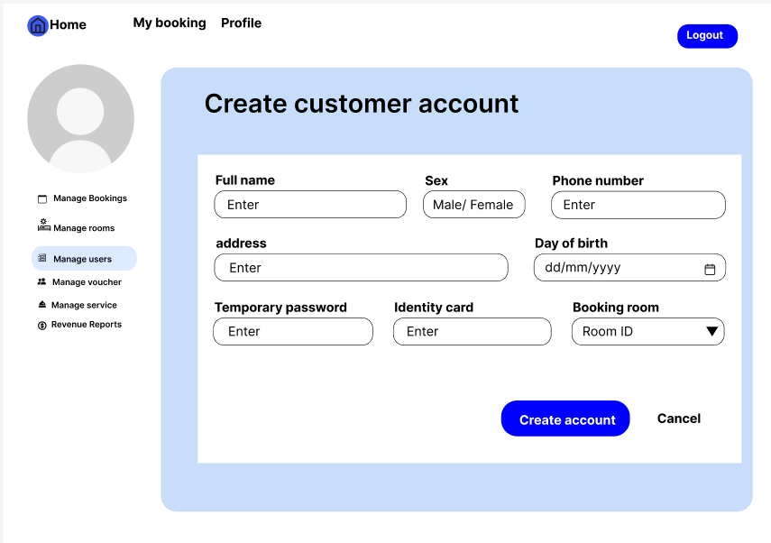
Actor: Admin
General description: Staff create an account for a walk-in guest and then book a room on the guest’s behalf.
No. | Control | Type | Constraints | Function and handling
1 | Full name, Sex, Phone number, address, Day of birth, Identity card | Text boxes, drop-down | Full name, phone number and ID card are required | Enter the guest’s information.
2 | Email | Text box | Required, not already registered | Used to log in and to receive the temporary password.
3 | Temporary password | Text box | Follows the password rules | Temporary password sent to the guest by email.
4 | Booking room | Room ID drop-down | Optional | Choose a room to book for the guest, together with check-in, check-out and number of guests.
5 | Create account | Button | None | Valid: create an account with the Customer role and return to the MANAGE USERS tab. Invalid: show an error.
6 | Cancel | Link | None | Discard and return to the MANAGE USERS tab.

MANAGE ROOMS tab
Figure: Add New Room
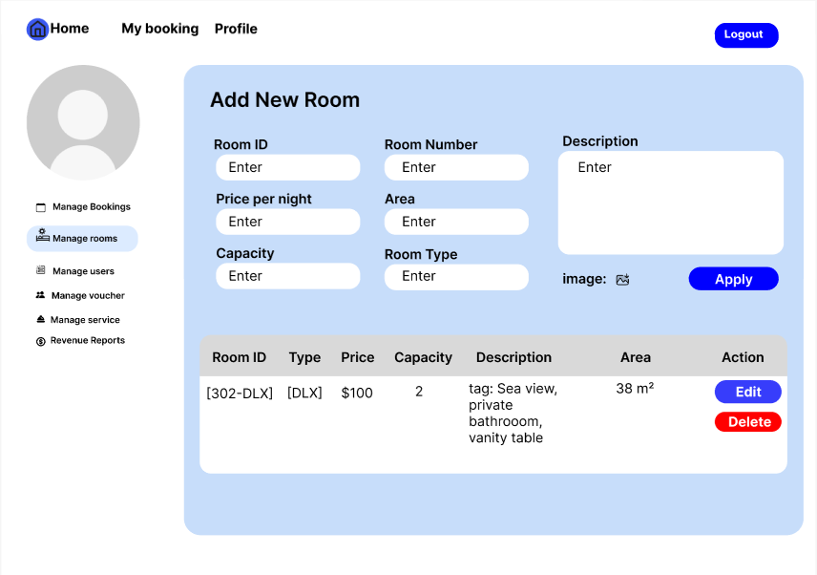
Actor: Admin
General description: Adds, edits and deletes rooms.
No. | Control | Type | Constraints | Function and handling
1 | Room ID, Room Number | Text box | Required, unique | Enter the room ID and number.
2 | Price per night, Area, Capacity | Number box | Not negative | Enter price, area (m²) and capacity.
3 | Room Type | Drop-down list | Required | Choose a room type; a new type can be added.
4 | Description | Text box | Optional | Describe the room.
5 | image | Upload button | Image formats | Upload room photos.
6 | Add room | Button | None | Save the new room and add it to the table.
7 | Room table | Table | Read-only | Room ID, Type, Price, Capacity, Description, Area.
8 | Edit | Button | None | Load the row into the form, edit and save.
9 | Delete | Button | None | Confirm, then delete. A room with active bookings cannot be deleted.

MANAGE VOUCHERS tab
Figure: Manage Voucher
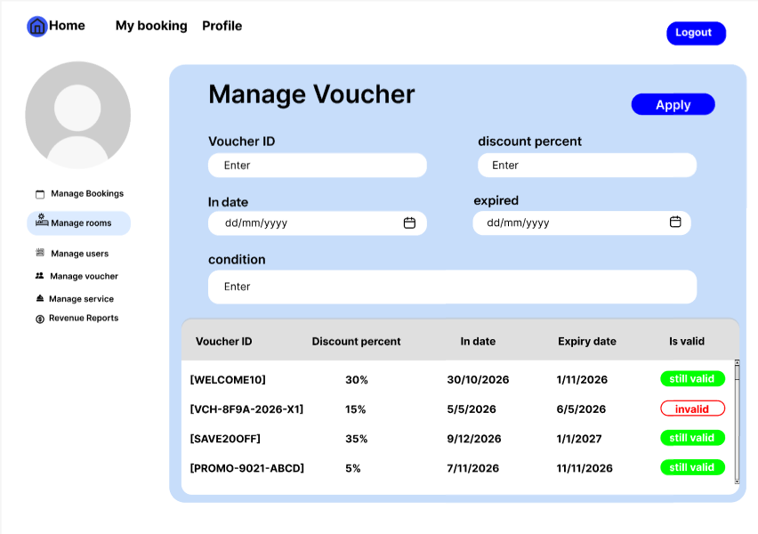
Actor: Admin
General description: Creates, edits and disables discount codes.
No. | Control | Type | Constraints | Function and handling
1 | Voucher ID | Text box | Required, unique | Enter the code.
2 | discount percent | Number box | From 1 to 100 | Enter the discount percentage.
3 | Start date, expired | Date picker | Expiry after start date | Set the validity period.
4 | condition | Text box | Optional | Enter the conditions of use.
5 | Apply | Button | None | Save a new voucher or update one and add it to the table.
6 | Table (Voucher ID, Discount percent, Start date, Expiry date, Is valid) | Table | Read-only | Is valid shows still valid, invalid or not started.
7 | Edit, Disable | Button | None | Edit or disable the voucher.

MANAGE SERVICES tab
Figure: Manage Service
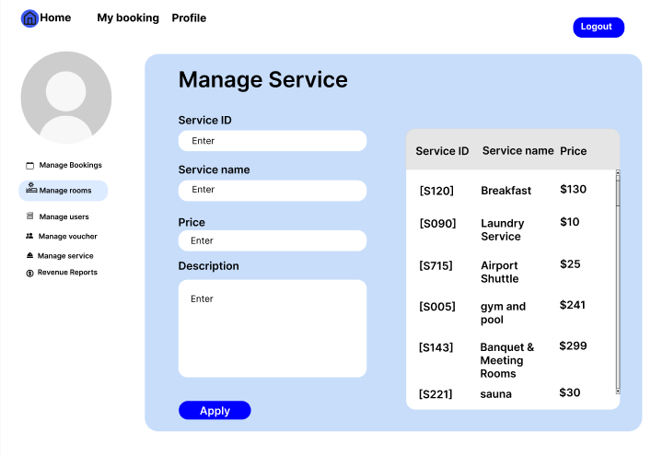
Actor: Admin (design to be added)
General description: Creates, edits and deletes extra services.
No. | Control | Type | Constraints | Function and handling
1 | Service ID, Service name | Text box | Required | Enter the service ID and name.
2 | Price | Number box | Not negative | Enter the service price.
3 | condition | Text box | Optional | Describe the conditions.
4 | Apply | Button | None | Save the service.
5 | Service table, Edit, Delete | Table, buttons | None | View, edit and delete services. Services are assigned to rooms on the MANAGE ROOMS tab.

